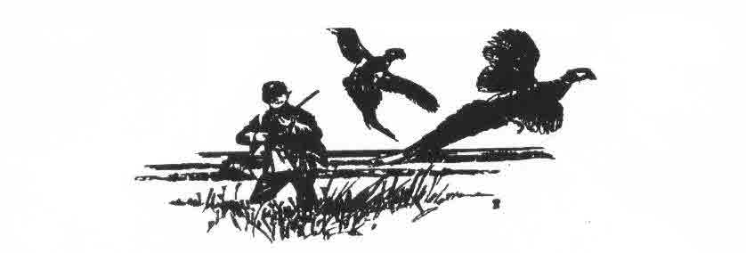
Badger Brittany Club Is Hosting an AKC & American Field Sanctioned Field Trial at Pine Island Wildlife Management Area
On June 9-10, 2018 entries Close Tuesday June 5th at 7:00 pm
Open to All Pointing Breeds
Junior Handler & Hunter Stakes are being offered But Entries Will Be Limited. Pheasants & Quail Will Be Planted On Course
No Birds are killed Blank Guns Only!
Lunch will be offered on the grounds!
Junior Handler: Running will start Saturday June 9 at 10:00 am
Open to youth 16 years old & under. A dog will be provided for those that do not have a pointing dog. Judgment is based on the dog handling ability of the youth.
Entry Fee: Free
Hunter Stake: Running will start Sunday June 10 at 10:00 am
Open to Pointing Breeds. Judging will be based on the AKC Gun Dog standards except that judging will end at flushing of the bird. No dog that has placed in an adult stake in an AKC or American Field or NAVHDA event can participate. No electronic collars! Entry Fee: $15.00

Only Blanks and Closed Barrel Guns Will Be Used! No birds will be killed

To Enter Contact: Jim Brigham at 608-233-3909 or
jwbrigham03@sbcglobal.net

