FIELD TRIAL
PREMIUM LIST #2023027656

AMERICAN BRITTANY CLUB
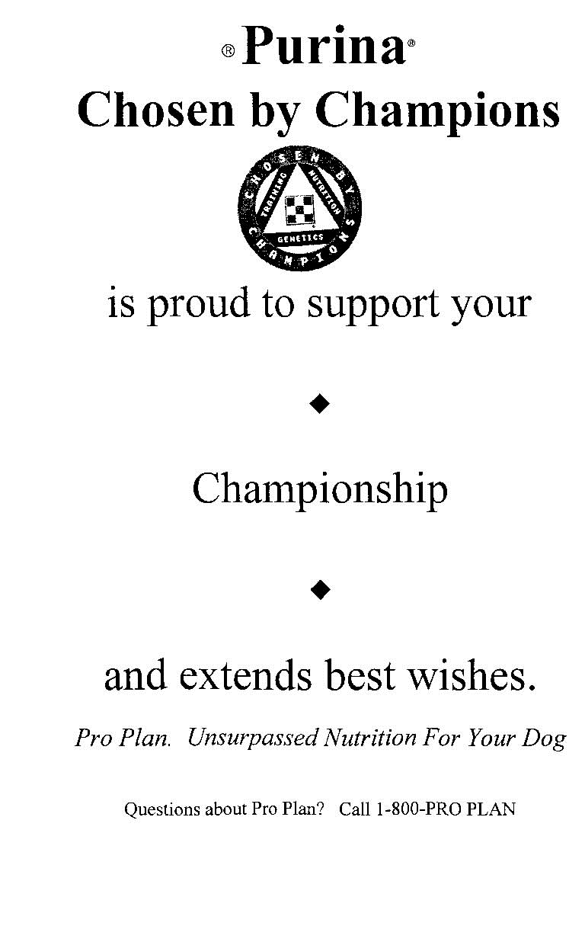

GROUSE & WOODCOCK CLASSIC/CHAMPIONSHIP
AKC Licensed Field Trial

October 12-13, 2023
Open to Brittanys Only
Bitches in Season May Compete
(Will run at the end of the stake)

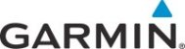

This Field Trial is Run Under the Rules and Procedures of the
American Kennel Club

Mail Advanced Entries To: Jim Brigham, Field Trial Secretary, 4130 Cherokee Drive, Madison, WI 53711 608-233-3909 – H 608-334-3909 – C
jwbrigham03@sbcglobal.net

Entries Will Close At: 7:00 PM Friday, October 6at 4130 Cherokee Drive, Madison, WI 53711

Drawing Will Take Place At: 7:30 PM, Friday, October 6 at 4130 Cherokee Drive, Madison, WI 53711

**********
JUDGES

Neil Boos Bradley Peterson
Bloomer, WI Cedar Grove, WI

STAKES SCHEDULE ENTRY FEE
Grand Open 8:00 a.m., Thursday, $150
Limited Gun Dog October 12-13, 2023
**********

COURSES AND BIRDS
Multiple 1-hour courses
Foot handled – no horses permitted on grounds
Native Ruffed Grouse and Woodcock

**********

BLANK AMMO ONLY! CLOSED BARREL GUNS ONLY!
209 Primer or .32 Caliber blanks must be used.

Tracking & GPS Collars will be allowed in Strict Accordance with AKC Regulations

ONLY BELLS MAYBE USED – NO BEEPER COLLARS
.**********
PRIZES

Trophies and Standard AKC rosettes to all placed dogs
Sponsors Awards Courtesy of Purina and Tri-Tronics
**********

OFFICERS
President: Robert Rankin, 2592 NW 234th Street, Edmond, OK 73025
Vice-President: Richard Beaver, 9975 Musgrave Rd., Wichita Falls, TX 76305
Secretary: Jennifer Brooke Burlingham, 731 Maple Grove Court,
Hope Mills, NC
Treasurer: Gerilyn Sennott, 352 Whitney Road, Lake Zurich, IL 60

**********
FIELD TRIAL COMMITTEE
Chairman: Bill Zwettler
Secretary: Jim Brigham
Members: John Kruse, Bob Powell, Bill Holtz, Roger King, Mike Dally

OFFICIAL AMERICAN KENNEL CLUB FIELD TRIAL or HUNT TEST ENTRY FORM

Club AMERICAN BRITTANY CLUB  GROUSE & WOODCOCK  CLASSIC/CHAMPIONSHIP |  |  |  |  |  | Date(s):  Oct. 12-13, 2023 |  |  |  |  |  | Event #:  2023027656
Location: Eau Claire County Forest near Augusta, WI |  | Event type (test/trial):  FIELD TRIAL |  |  |  |  | Enter in Stake/Test:  GRAND OPEN LTD GUN DOG
FDSB #:  AKC No. AKC Litter No. ILP No. ________________  ____________________ |  |  |  |  |  |  |  |  | I enclose entry fees  in the amount of: $150
Full Name of Dog:

Breed:  BRITTANY | Reg #: |  |  | Call Name: |  |  |  | Sex: |  |  | Date of Birth:
Sire:

Dam:

Name of Breeder:

Actual Owner(s):

Owner’s Address:

City: |  |  |  |  | State: |  |  |  |  | Zip:
Name of Owner’s Agent/Handler:

Agent/Handler’s Address:

City: |  |  |  |  | State: |  |  |  |  | Zip:
AKC Rules, Regulations, Policies and Guidelines are available on the American Kennel Club website:www.akc.org
AGREEMENT
I certify that I am the actual owner of the dog, or that I am the duly authorized agent of the actual owner whose name I have entered above. In consideration of the acceptance of this entry, I (we) agree to abide by the rules and regulations of The American Kennel Club in effect at the time of this event, and any additional rules and regulations appearing in the premium list of this event and entry form and any decision made in accord with them. I (we) agree that the club holding this event has the right to refuse this entry for cause which the club shall deem sufficient. In consideration of the acceptance of this entry and of the holding of this event and of the opportunity to have the dog judged and to win prizes, ribbons, or trophies, I (we) agree to hold the AKC, the event-giving club, their members, directors, governors, officers, agents, superintendents or event secretary and the owner and/or lessor of the premises and any provider of services that are necessary to hold this event and any employees or volunteers of the aforementioned parties, and any AKC approved judge, judging at this event, harmless from any claim for loss or injury which may be alleged to have been caused directly or indirectly to any person or thing by the act of this dog while in or about the event premises or grounds or near any entrance thereto, and I (we) personally assume all responsibility and liability for any such claim; and I (we) further agree to hold the aforementioned parties harmless from any claim for loss, injury or damage to this dog. Additionally, I (we) hereby assume the sole responsibility for and agree to indemnify, defend and save the aforementioned parties harmless from any and all loss and expense (including legal fees) by reason of the liability imposed by law upon any of the aforementioned parties for damage because of bodily injuries, including death at any time resulting therefrom, sustained by any person or persons, including myself (ourselves), or on account of damage to property, arising out of or in consequence of my (our) participation in this event, however such, injuries, death or property damage may be caused, and whether or not the same may have been caused or may be alleged to have been caused by the negligence of the aforementioned parties or any of their employees, agents, or any other persons. I (WE) AGREE THAT ANY CAUSE OF ACTION, CONTROVERSY OR CLAIM ARISING OUT OF OR RELATED TO THE ENTRY, EXHIBITION OR ATTENDANCE AT THE EVENT BETWEEN THE AKC AND THE EVENT-GIVING CLUB (UNLESS OTHERWISE STATED IN TIS PREMIUM LIST) AND MYSELF (OURSELVES) OR AS TO THE CONSTRUCTION, INTERPRETATION AND EFFECT OF THIS AGREEMENT SHALL BE SETTLED BY ARBITRATION PURSUANT TO THE APPLICABLE RULES OF THE AMERICAN ARBITRATION ASSOCIATION. HOWEVER, PRIOR TO ARBITRATION ALL APPLICABLE AKC BYLAWS, RULES, REGULATIONS AND PROCEDURES MUST FIRST BE FOLLOWED AS SET FORTH IN THE AKC CHARTER AND BYLAWS, RULES, REGULATIONS, PUBLISHED POLICIES AND GUIDELINES.
Signature of owner or his
agent duly authorized to make this entry: ______________________________________________
Telephone: |  |  | Email address:

